Slide 68

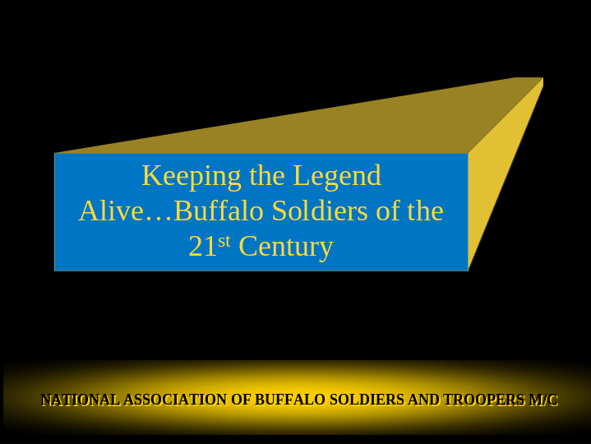

The Legacy lives on for the Buffalo Soldiers

Slide 69

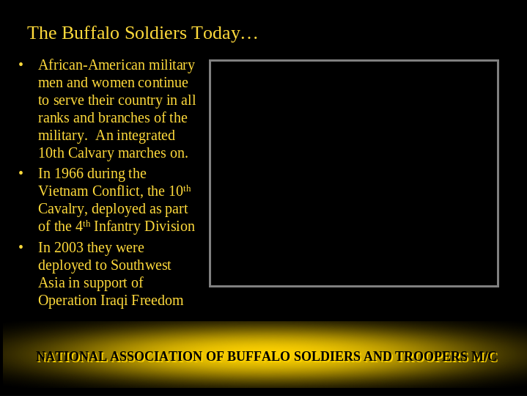

As Blacks have now become a regular part of the US Military they continue to serve in all aspects and in all ranks. There are not too many “firsts” still to be achieved.

The US military regularly keeps the names of historic units alive. The 10tb Cavalry is one of those units. It was deployed in 1966 during the Vietnam war as part of the 4th Infantry Div

In 2003 it was deployed to Southwest Asia in support of “Operation Iraqi Freedom”

Slide 70

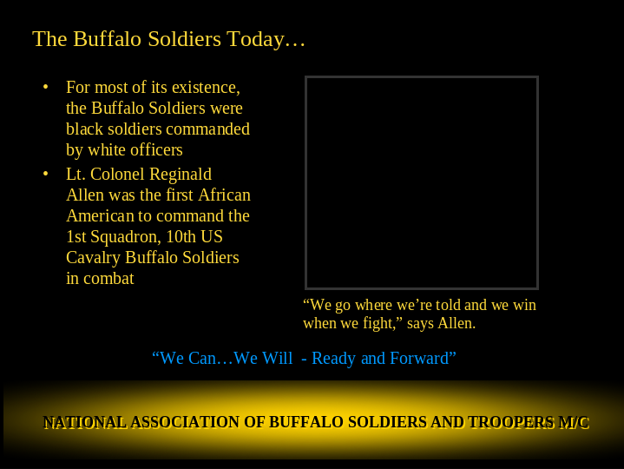

For most of it’s existence the Buffalo Soldiers were commanded by White Officers.
Lt Col Reginald Allen was the first Black to command the 1st Squadron, 10th US Cavalry Buffalo Soldiers.

Slide 71

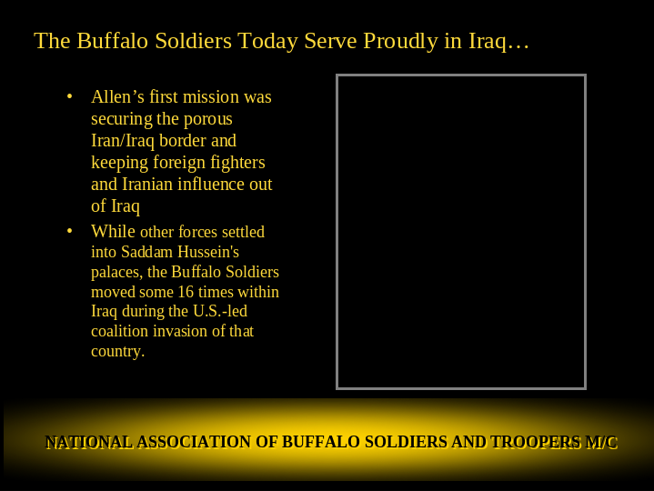

Slide 72

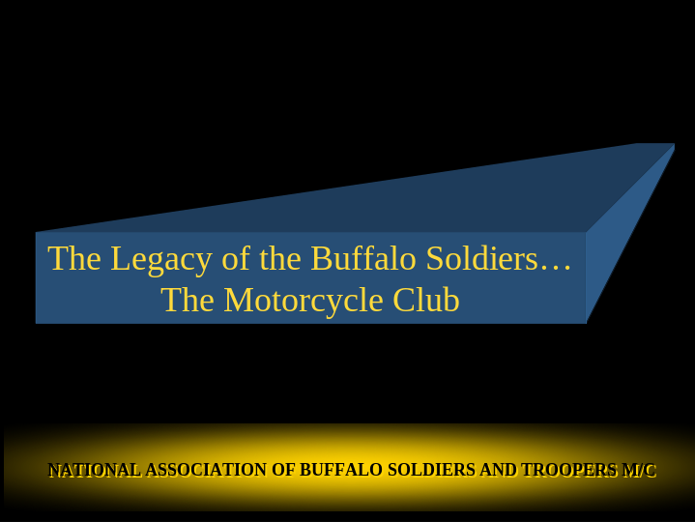

Now I’ll discuss the history of the Buffalo Soldiers Motorcycle Club

Slide 73

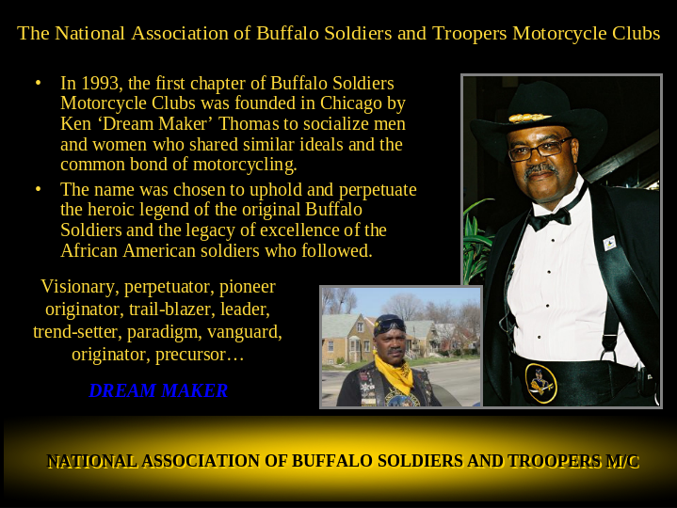

First chapter formed in 1993 in Chicago by Ken Thomas – Dream Maker

Slide 74

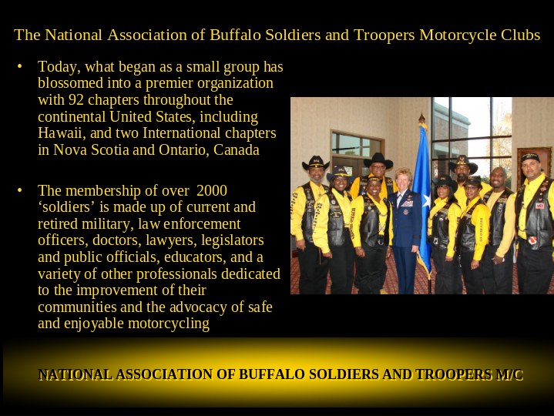

As the Chicago club traveled across the country more and more bikers decided to form chapters in their area. In 1999 the NABSTMC was formed to bring these chapter together under one umbrella. There are now 92 chapters across the US and Canada.

Slide 75

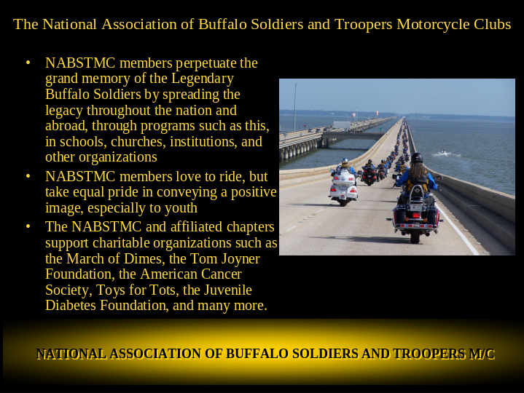

It is our mission to tell the story of the Buffalo Soldiers and to present a positive image to all people. We support charities, offer scholarships and mentor our youth.

Slide 76

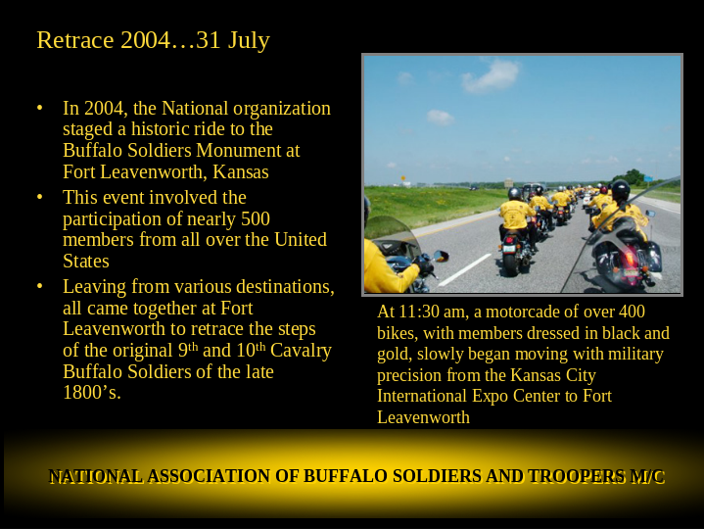

In 2004 the NABSTMC organized a ride to the monument at Ft Leavenworth and held a ceremony to pay tribute to the original Buffalo Soldiers.

Slide 77

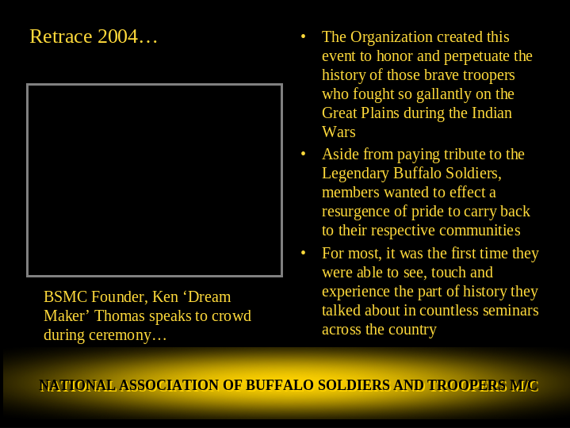

They wanted to remember the men who fought the Indian Wars and also and most importantly for the club, this gathering spurred them all to return home and educate the public about these men invisible men of honor who served their country.

Slide 78

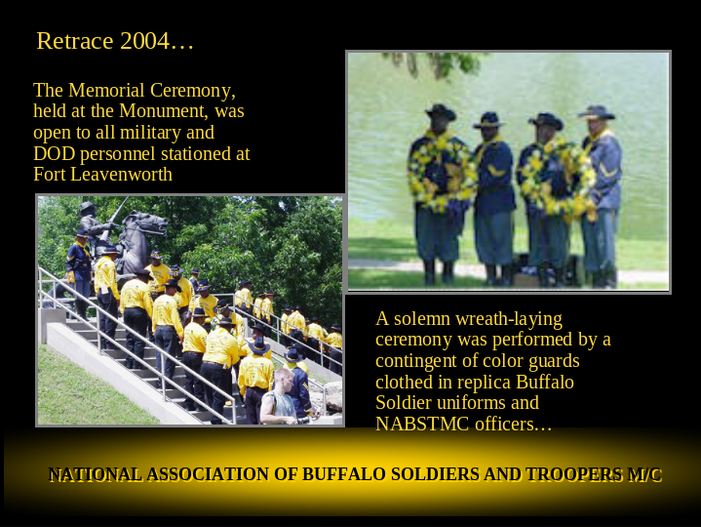

The ceremony was attended not only by members of our association but also by men and women of the military

Slide 79

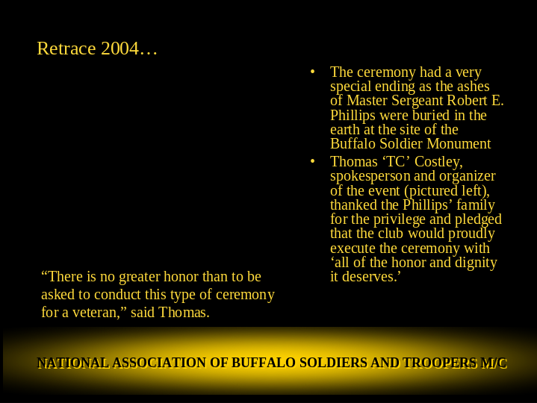

The ashes of MSGT Robert E Phillips were buried at the site during the cermony.

Slide 80

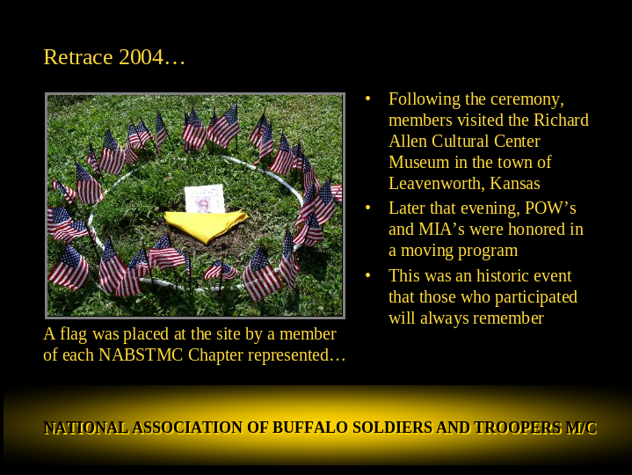

Each chapter that was present planted a flag at the site.

Slide 81

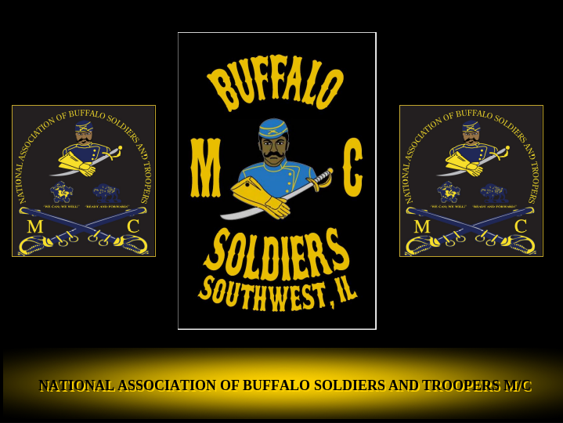

This concludes our presentation. We hope that you enjoyed it and more importantly, that you learned some of the history of the Buffalo Soldiers. This is American History that involved the deeds of Black Men. This is not just African-American history that should be dusted off every February and told to the masses. Continue to increase your knowledge of this topic and share it with people that you come across, both young and old and of all races. Encourage them to look for more information on the Buffalo Soldiers. And if you ride and meet our criteria, come on out and be a modern day Buffalo Soldier. We have traded the horses of muscle and flesh for iron horse. Buffalo Soldiers still are riding with pride with their heads held high.
Thank you all.

